# Ch2 Literature Review

A literature review is a critical analysis of published literature on a specific topic or research question. It involves identifying, evaluating, and synthesizing relevant literature to provide a comprehensive understanding of the current state of knowledge on the topic. Literature reviews are commonly used in academic research to identify gaps in the literature, build a theoretical framework, and provide a context for the research study. (Grant, M. J., & Booth, A. 2009)

The most pertinent application frameworks that are comparable to ours will be discussed in this chapter, and they all aim to offer services for online electronic product sales as well as services to help shop owners market their goods. In addition to screenshots of their primary screens, this chapter provides a general overview of how these systems function, their key features, and what they lack. Overall, a literature review about an online marketplace system for electronic products involves gathering and analyzing relevant research and literature related to the topic.

.

## Related Systems

## Swappa website:

Swappa, a marketplace founded in 2010 by Ben Edwards, specializes in facilitating the buying and selling of owned electronics, like smartphones, laptops, and tablets. Through Swappa's platform, sellers can easily list their items for sale, while buyers can browse and directly purchase from them. The user-friendly interface of Swappa enables communication between buyers and sellers for negotiations and smooth transactions.

One of the advantages of using Swappa is that buyers can find devices at affordable prices compared to new ones. The platform ensures efficient transactions, allowing sellers to list their items within minutes while enabling buyers to complete purchases with a few clicks. Moreover, Swappa empowers sellers by giving them the ability to set their prices and engage in negotiations with buyers. To further enhance the experience, Swappa provides customer support services for both buyers and sellers.

There are pros and cons to using Swappa as a marketplace for used electronics. One con is that it's only available to customers in the United States, so it has limited coverage. Another aspect that could be improved is the search and filtering options on Swappa, like searching on a post by ads owner location, as they could be improved to help buyers find what they're looking for easily. Moreover, they do not provide real time text chatting to enable users to communicate in real time. Additionally, there's also the issue of seller fees on Swappa, as they charge a fee for each transaction. which may not be as competitive as other online marketplaces that offer free listings.

|  |  |
| --- | --- |
| **Swappa website** | |
| **Advantages** | **Disadvantages** |
| 1. Easy to use and Simple to remember. 2. Swappa offers a user-friendly platform for buying and selling electronics. 3. Users can register and login. 4. Clean interface. | 1. Available in United States only. 2. Location-based searches are not available to users. 3. The user cannot add a list of liked ads. 4. Swappa charges a flat fee for each transaction. 5. Not provide real time text chatting to enable users to communicate. |

Table 2-1 above shows the advantages and disadvantages in the Swappa website.

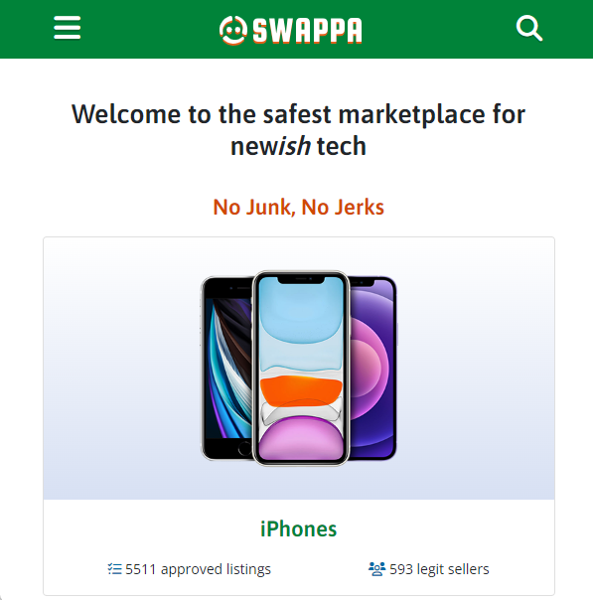

*Figure 2.1.1: Home page of Swappa website.*

Figure 2.1 above presents a screenshot of home page from Swappa website.

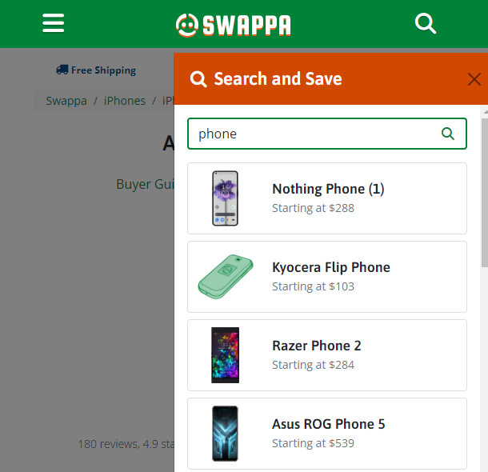

*Figure 2.1.2: Search process in Swappa website*

Figure 2.1.2 in the above represents the search process Swappa website.

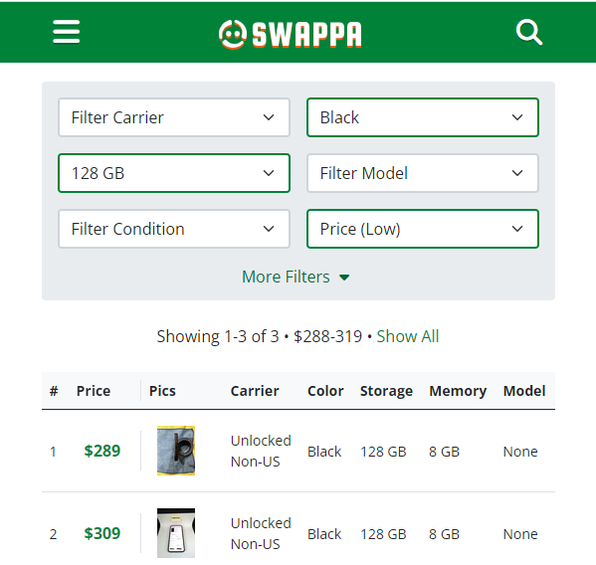

*Figure 2.1.3: filter form 1* Swappa *website Figure 2.1.4: filter form 2* Swappa *website*

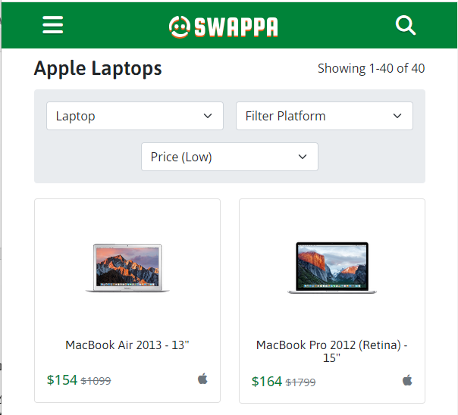

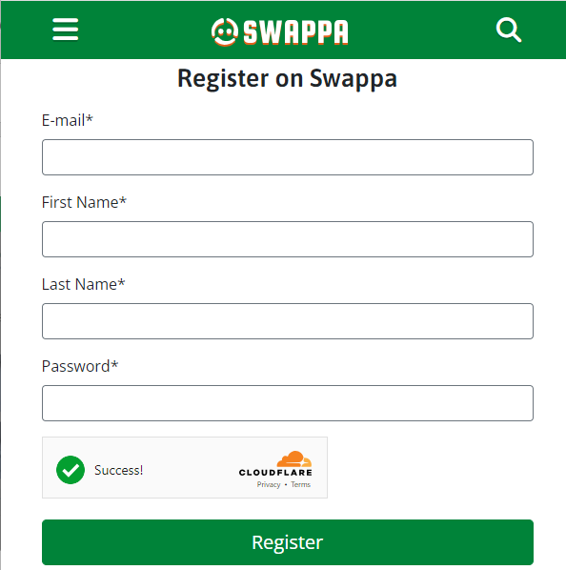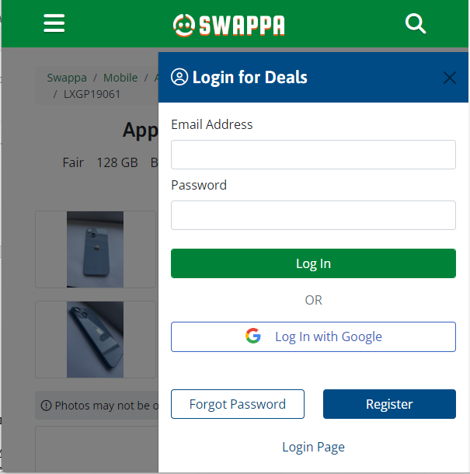

*Figure 2.1.5: Login form* Swappa *website. Figure 2.1.6: Register form* Swappa *website.*

## eBay website:

In 1995, Pierre Omidyar founded eBay, a well-known online shopping company, in San Jose, California. The main goal of this corporation was to establish a platform where people could trade goods and services. eBay's primary strategy involves connecting buyers and sellers and offering a digital space for transactions. Additionally, eBay provides various resources to support sellers, including tools for item listing, management, payment processing, and shipping aid.

eBay boasts advantages that make it highly favored by both buyers and sellers. Its extensive user base ensures visibility for sellers offerings, while its scalability enables the handling of large transaction volumes. However, there are some drawbacks to consider, such as the fees associated with listing items. Additionally, given the abundance of features and options on eBay, it can be perceived as complex.

eBay provides sellers with a variety of tools and services that are designed to assist them in managing their listings, completing transactions, and addressing customer service queries. While these functionalities can be advantageous for sellers who have experience, they may also feel overwhelming for users or individuals who are unfamiliar with the platform, and as Swappa company they do not provide real time text chatting to enable users to communicate in real time.

|  |  |
| --- | --- |
| eBay **website** | |
| **Advantages** | **Disadvantages** |
| 1. Available in many countries. 2. eBay offers a wide range of tools and services for sellers and buyers. 3. Handle large amounts of transactions. 4. Users can search by seller location. 5. The user can add a list of liked ads. | 1. eBay charges fees for listing items. 2. eBay's platform may be complex and difficult to navigate, particularly for new users. 3. Not provide real time text chatting to enable users to communicate. |

Table 2-2 above shows the advantages and disadvantages in the eBay website.

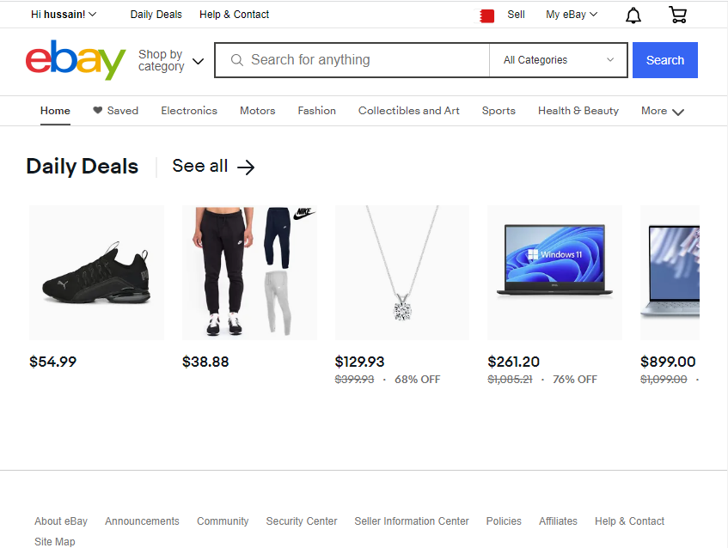

*Figure 2.2.1: Home page of eBay website.*

Figure 2.2 above presents a screenshot of home page from eBay website.

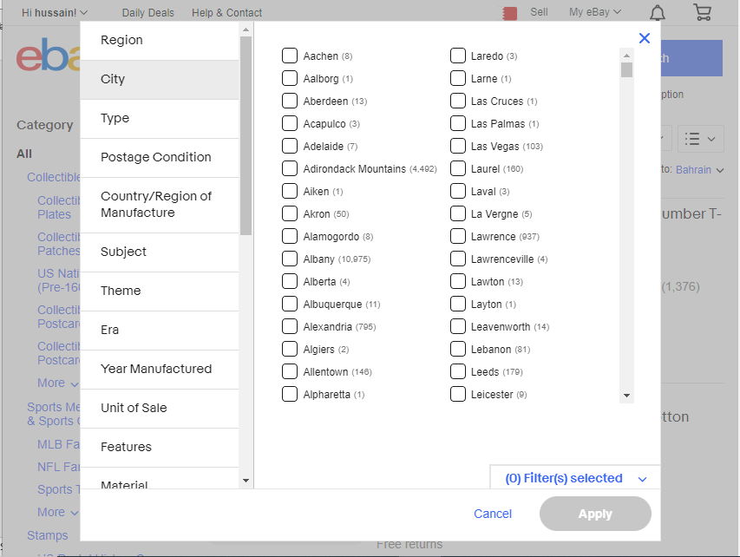

*Figure 2.2.2: Search process in eBay website.*

Figure 2.2.2 in the above represents the search process eBay website

which shows a strong algorithm in search and gives users many options in the search process.

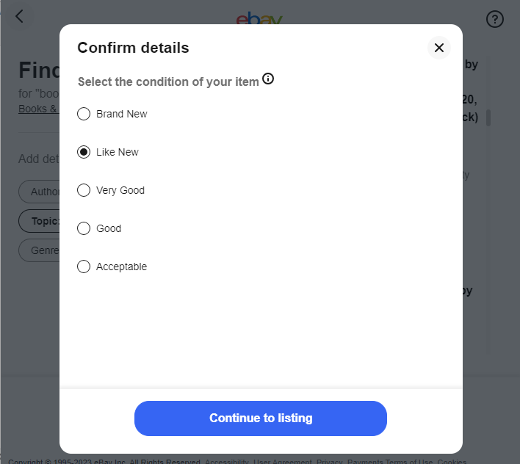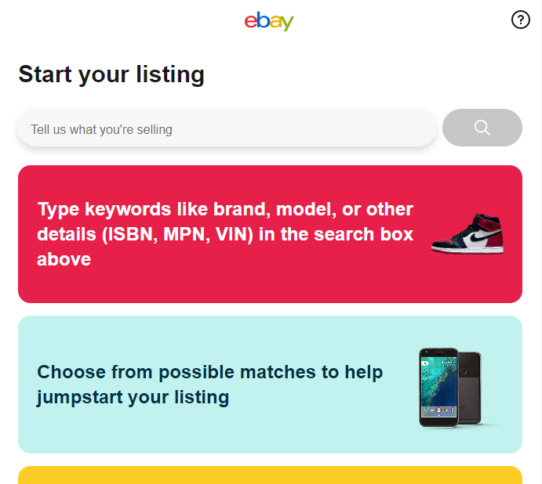

*Figure 2.2.3: step 1: Define what you are listing Figure 2.2.3: step 2: Define the state of what you are listing*

*. .*

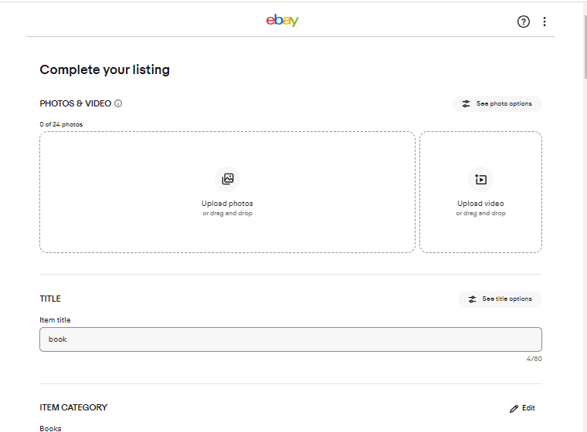

*Figure 2.2.3: step3:* Define a detailed description of what you're listing, along with images and videos.

Figure 2.2.3 above presents a screenshot of listing process in eBay website

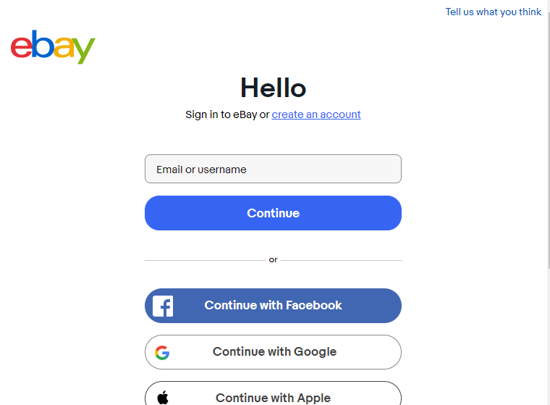

*Figure 2.2.4: Login form eBay website*

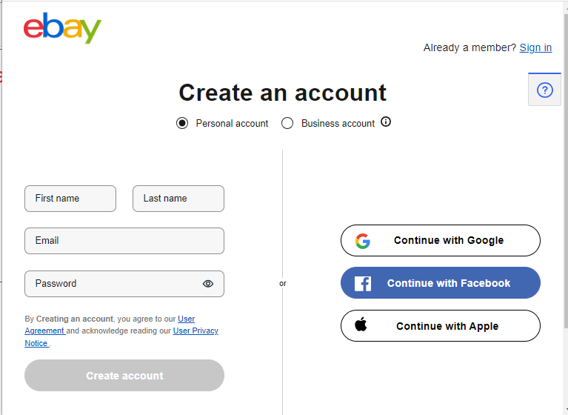

*Figure 2.2.4: Register form eBay website*

## Summary of Literature Review:

In summary, both eBay and Swappa have their own features and benefits as online marketplaces, but they also come with some limitations.

eBay has established itself as a platform with a user base offering a robust environment for buying and selling goods and services. It provides sellers with tools to manage their listings and transactions. The scalability of eBay allows it to handle transaction volumes, ensuring visibility for seller’s offerings. However, the fees associated with listing items and the complex nature of the platform can be seen as drawbacks.

On the other hand, Swappa focuses on facilitating the buying and selling of used electronics, providing an alternative to new devices. Its user-friendly interface and streamlined listing process make it convenient for sellers, while buyers can find devices at a reasonable price. Swappa empowers sellers by allowing them to set their prices and engage in negotiations. However, there is room for improvement in terms of expanding coverage beyond the United States and enhancing search and filtering options. Additionally, compared to platforms that offer listings, the seller fees on Swappa may not be as competitive.

However, we have noticed that both companies do not have functions that enable users to communicate with each other via text messaging in real time.

Throughout this chapter, we examined each application and looked at what it lacks as well as what makes it unique. Thus, we were able to determine what features an online marketplace system should possess and what should be avoided.

**References:**

Grant, M. J., & Booth, A. (2009). A typology of reviews: An analysis of 14 review types and associated methodologies.